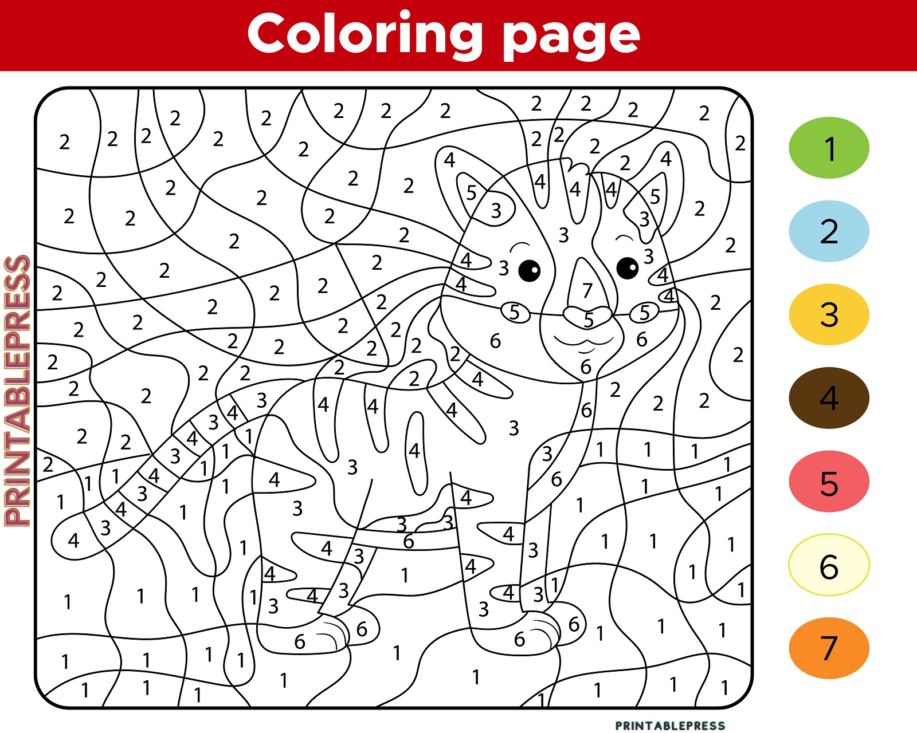
Color by Number for Kids: Printable PDF, Word and Free Download Online Free

